# Passive footprinting & Reconnaissance

## Step 1: Domain Information Gathering

Domain name chosen-example.com

* Used whois to find domain registration details.
* Used dig or nslookup to identify DNS records.

### Tools: whois, dig, nslookup.

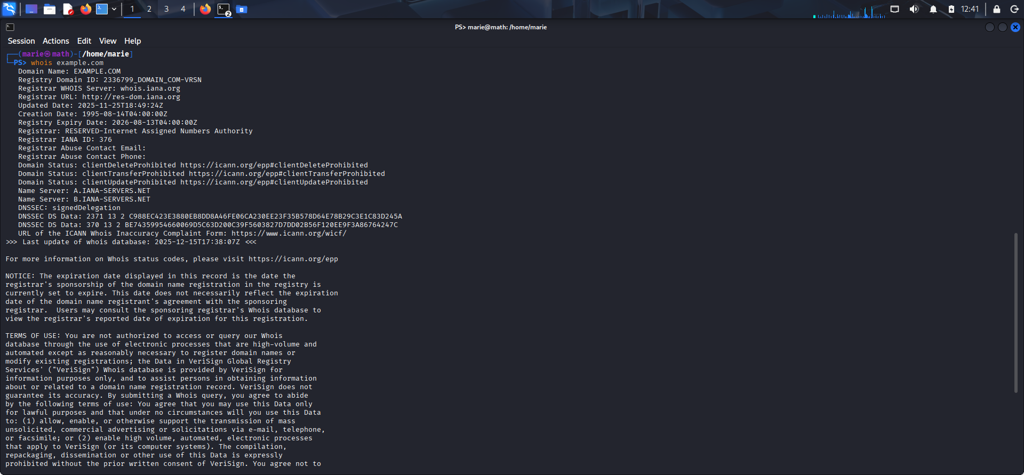

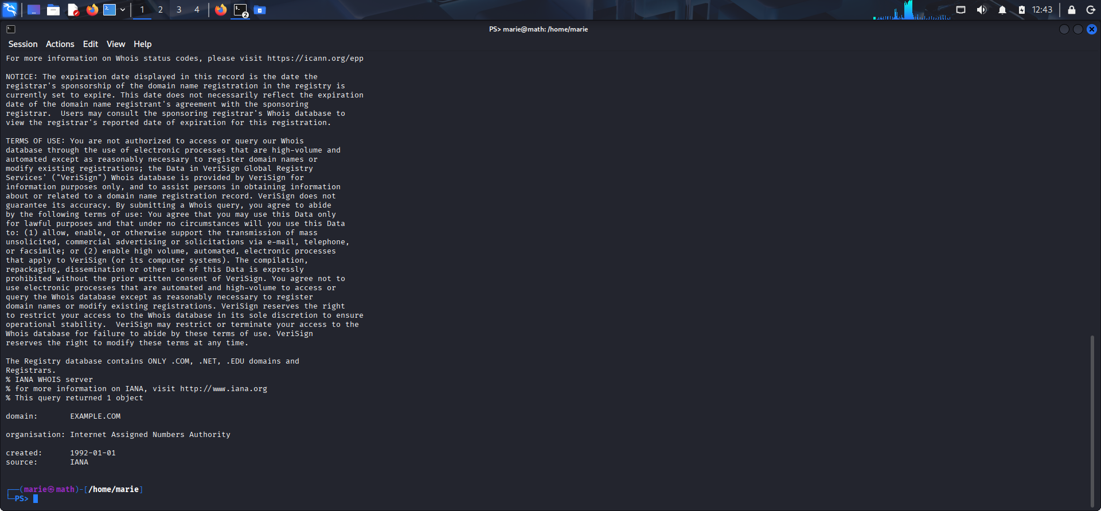

## Step 2: Subdomain Enumeration

## Performed passive subdomain discovery using tools like:

## subfinder

## Assetfinder

## Amass (in passive mode)

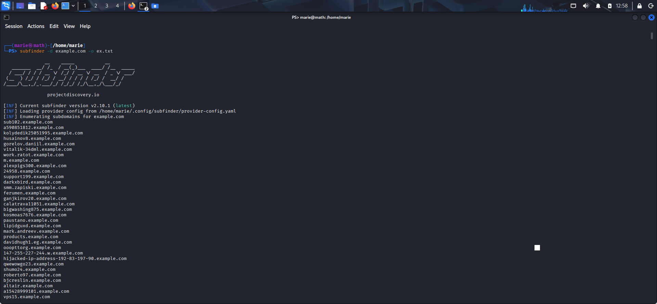

## Step 3: Email & Employee Information

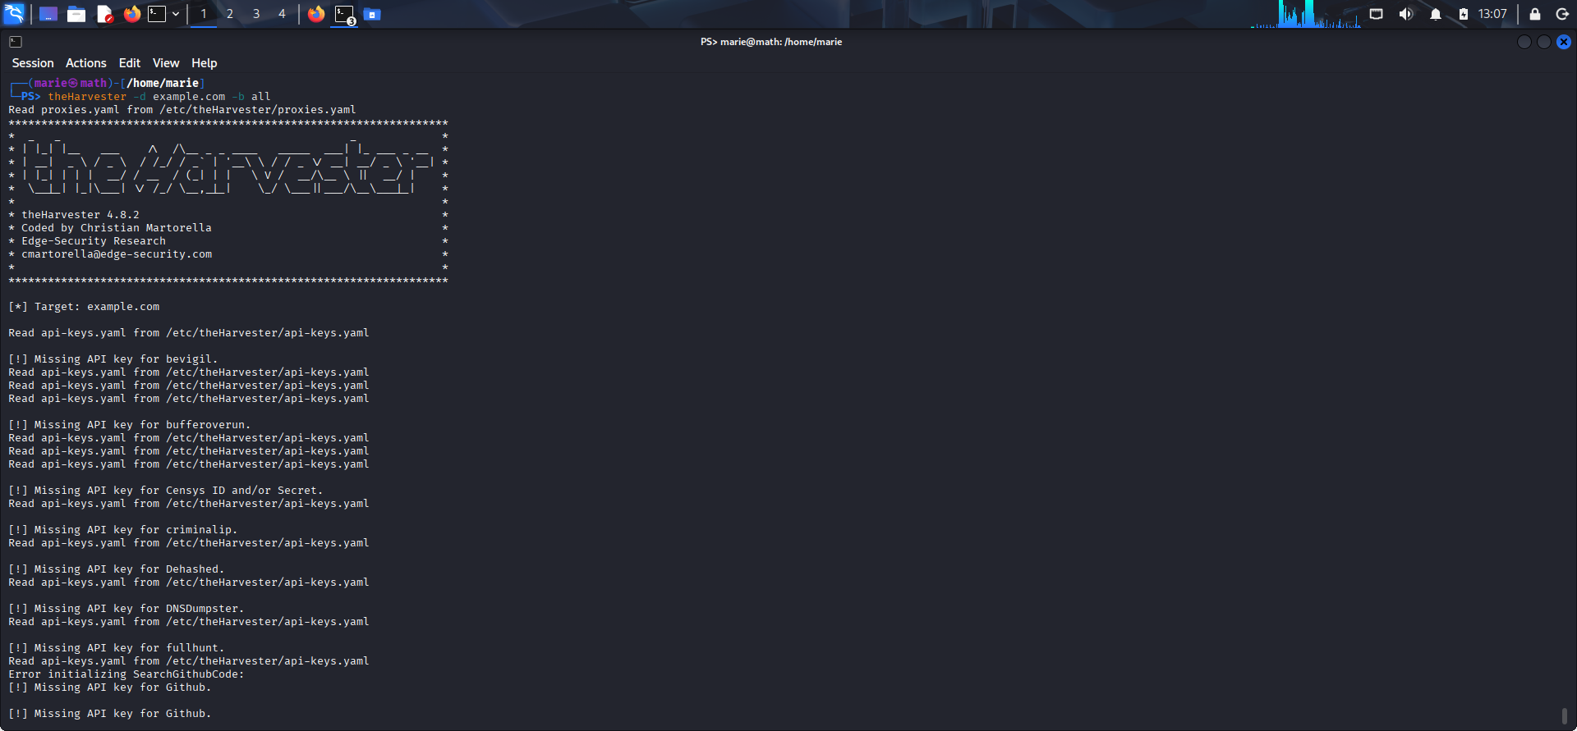Used theHarvester to gather emails, names, and hosts from public sources (Google, Bing, LinkedIn, etc.).

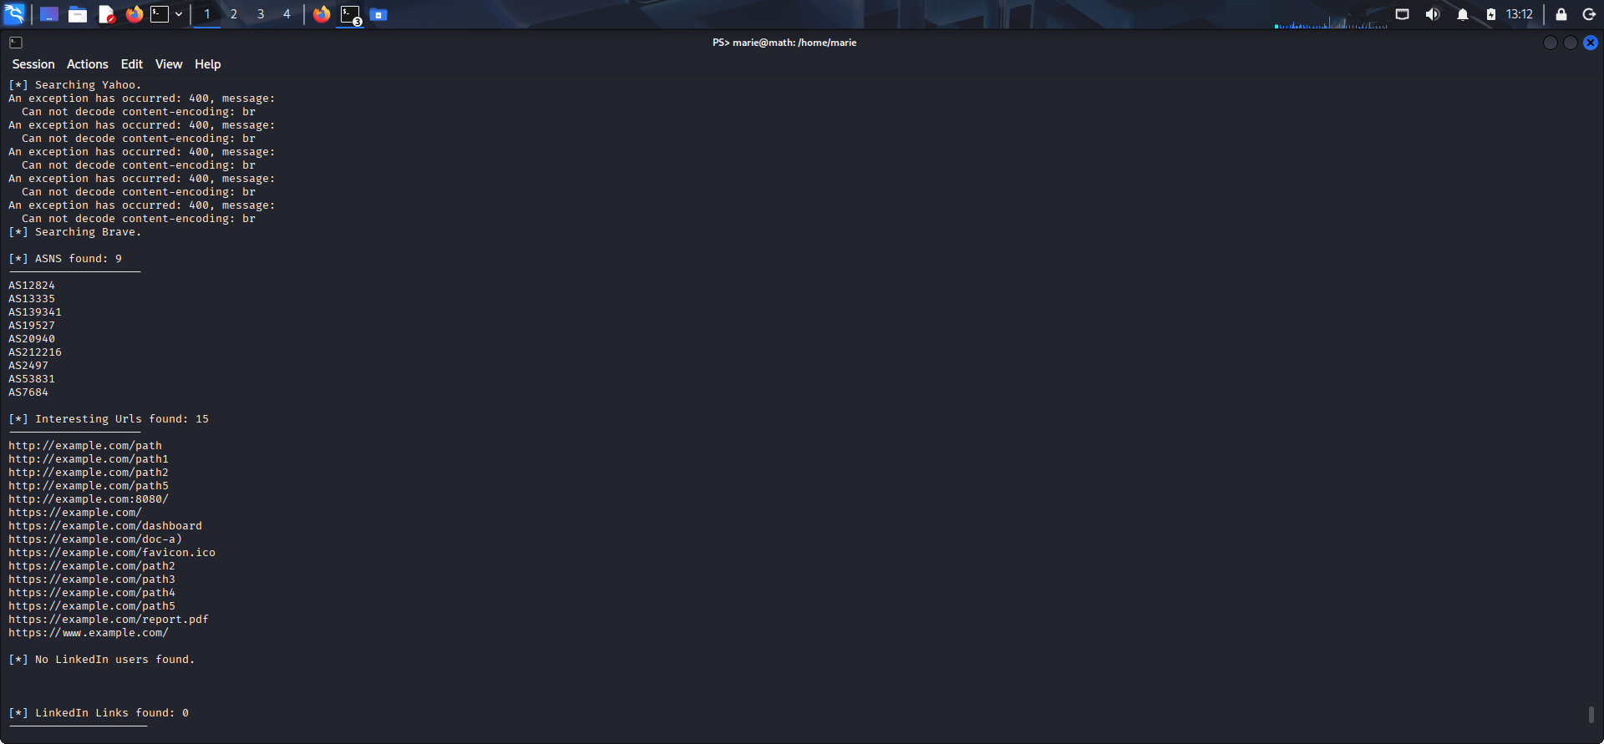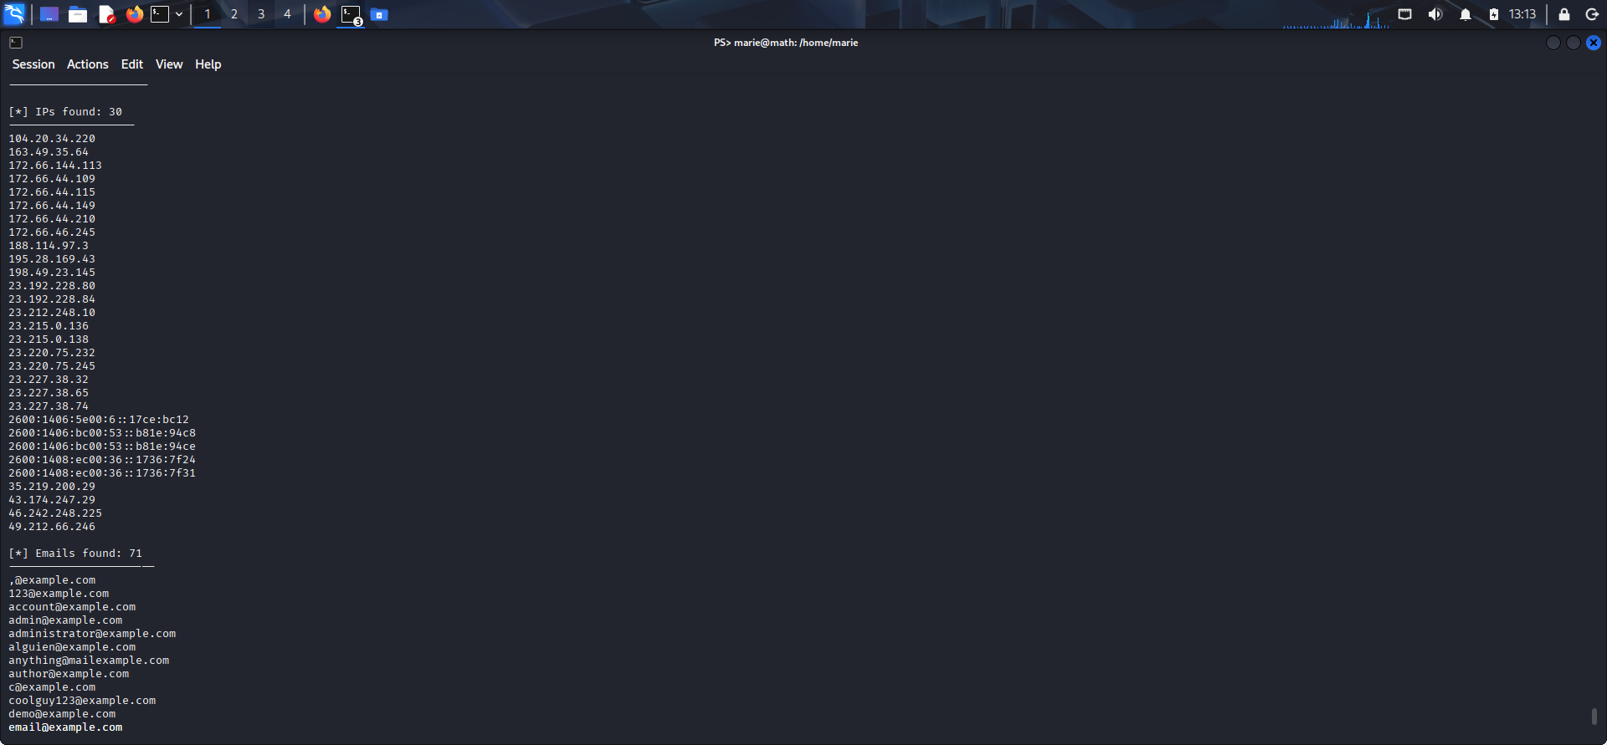

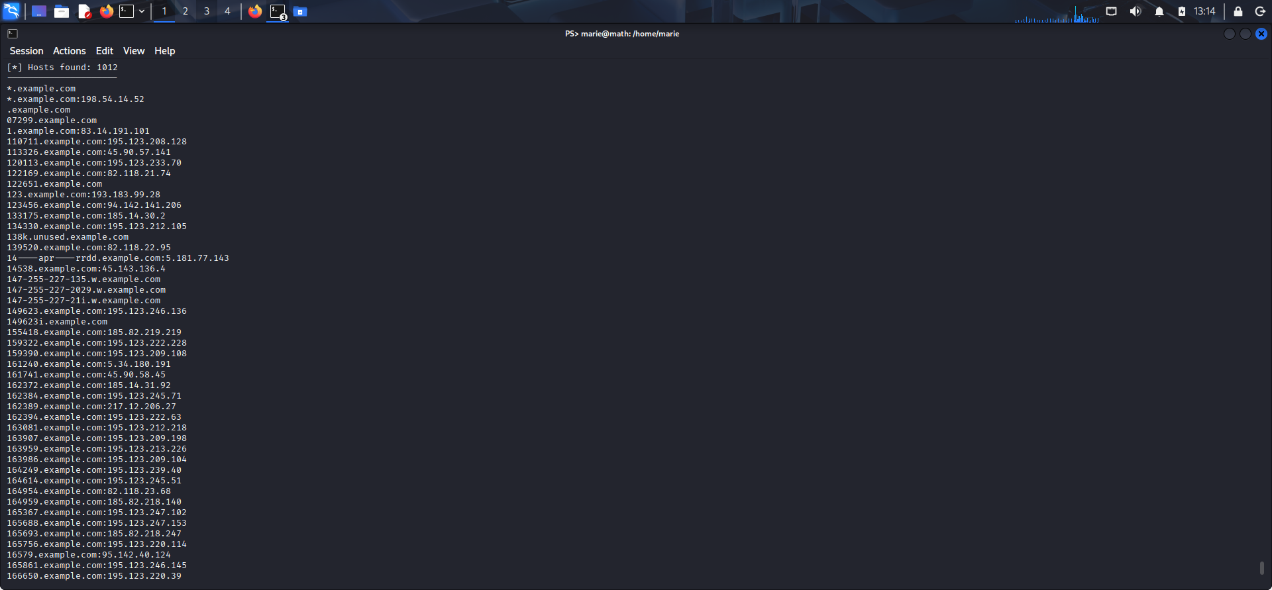

# Step 4: Metadata Extraction

Tried to Download publicly available documents (PDF, DOCX, PPTX) and analyze metadata. Tool: exiftool, strings, metagoofil.

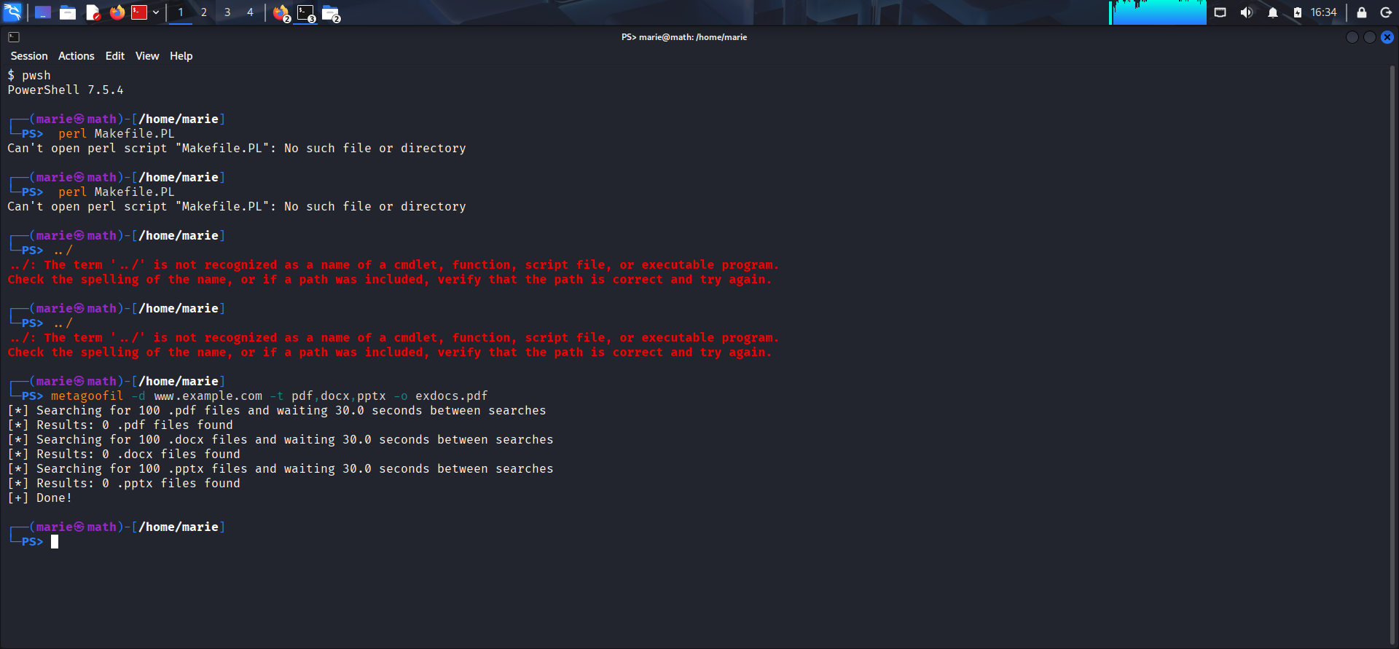

# Step 5: Google Dorking

Used Google search queries to find sensitive information.Example:

* site:example.com filetype:pdf
* site:example.com intitle:index of

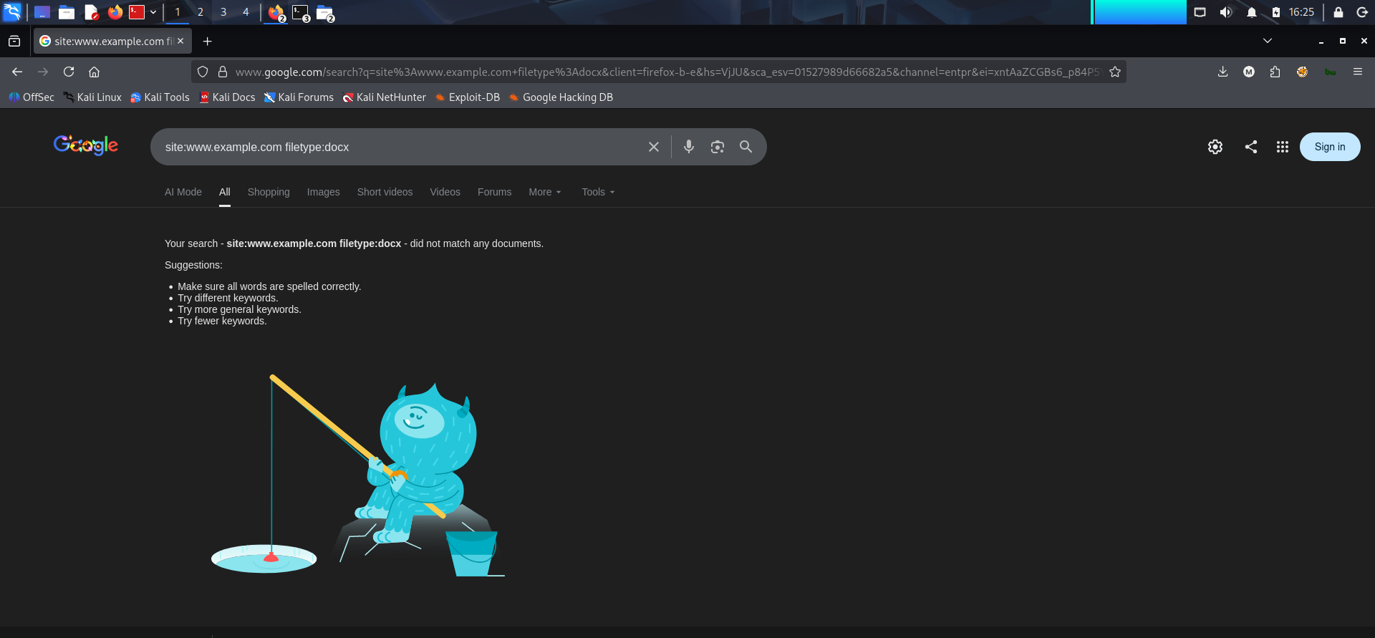

## 

## Step 6: Social Media & Open Source Intelligence (OSINT)

Identified target presence on LinkedIn, Twitter, GitHub, etc.

**Tools: Maltego, SpiderFoot.**

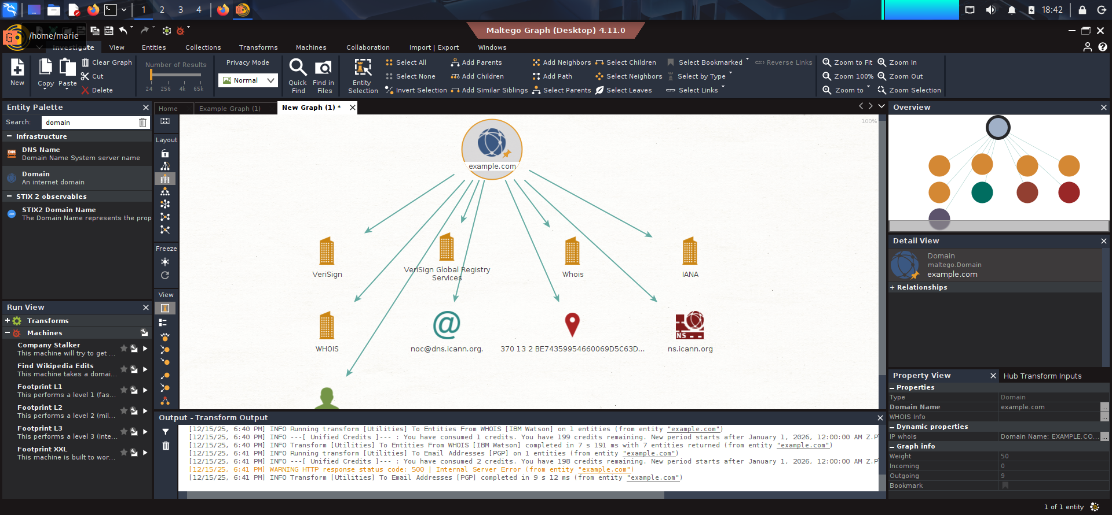

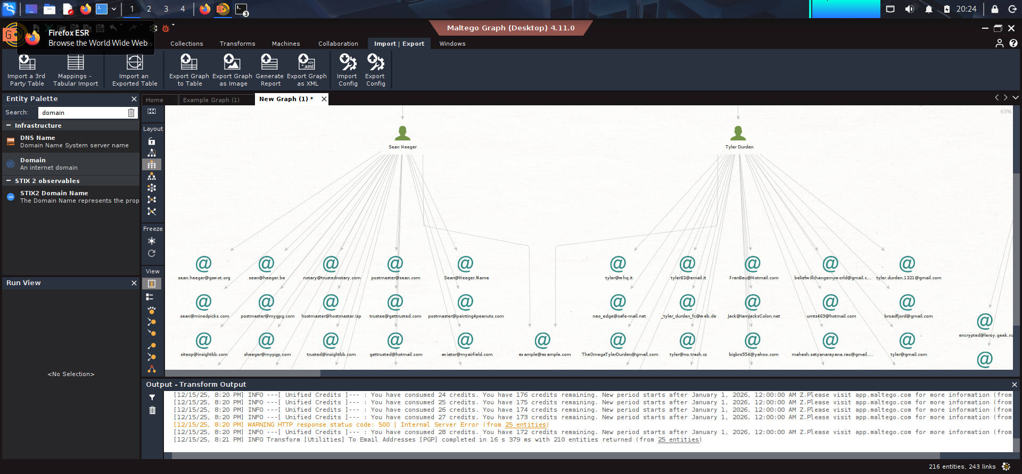

## 

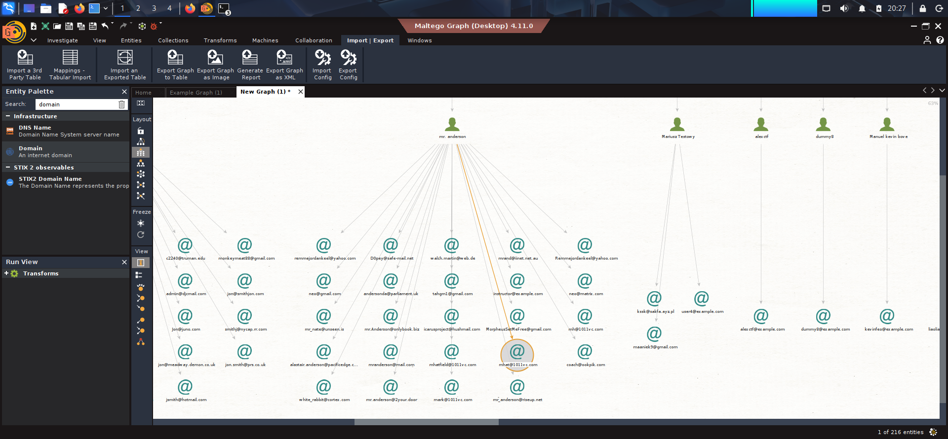

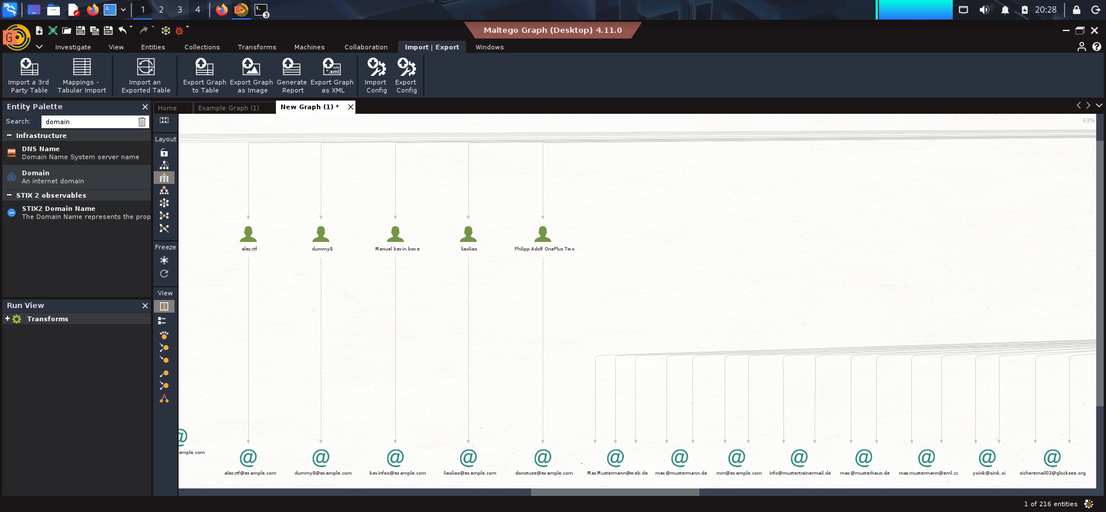

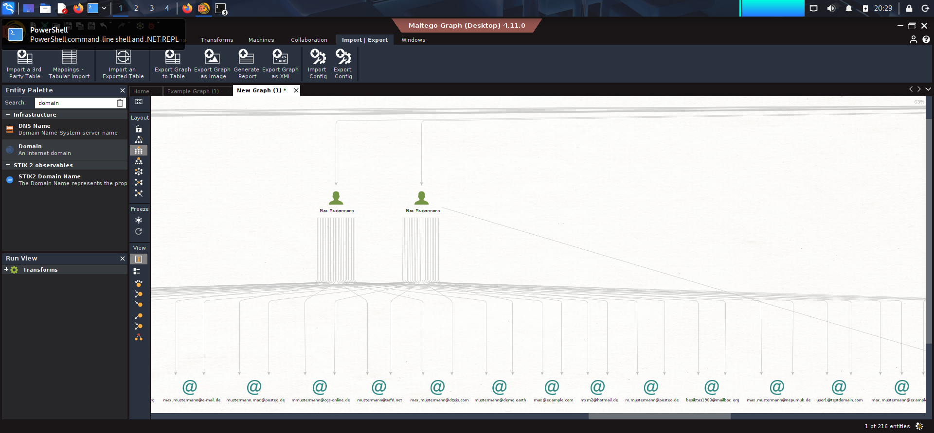

## 

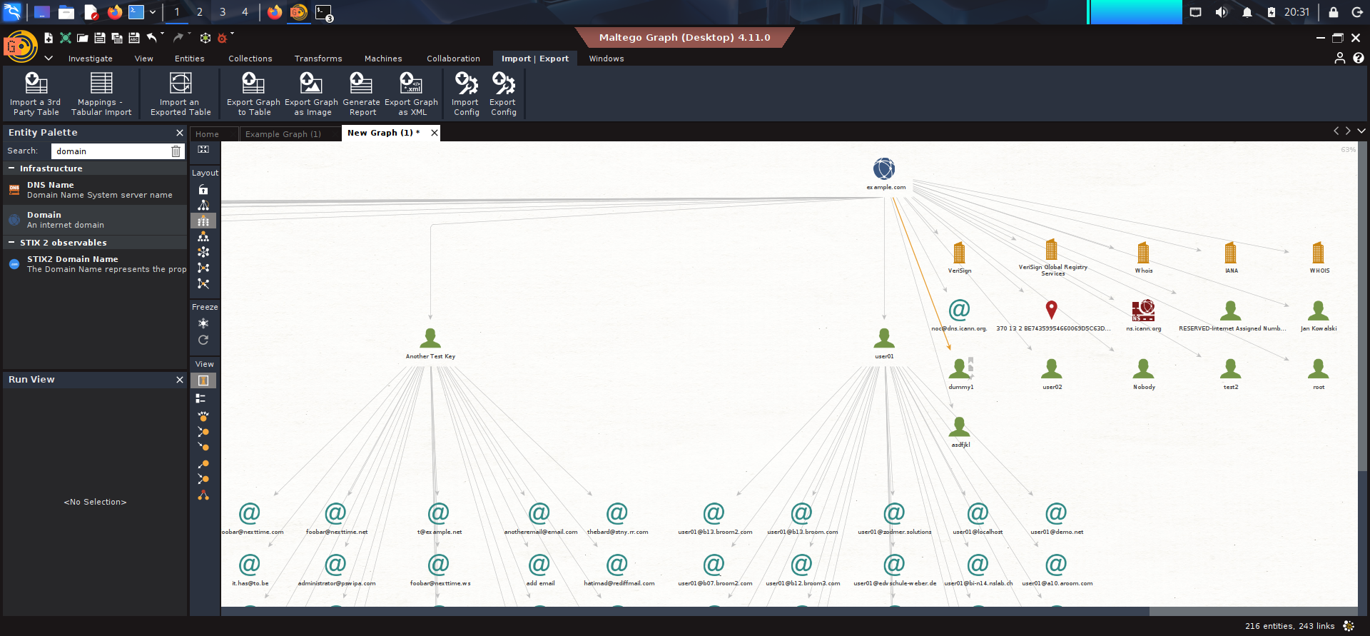

## Step 7 : Collected all the urls of the target & filter JS files

**Tools** **used for collecting urls**:Katana,GAU,Waybackurls

